DRAFT CONSENT CONDITIONS
NORTHERN REGIONAL PLANNING PANEL

PANEL REFERENCE & DA NUMBER | PPSNTH-141 – DA2022/0107
PROPOSAL | Extractive industry up to 300,000 tonnes per annum
ADDRESS | Lot 2 DP 1196757, 1465 Bentley Road, Bentley NSW 2480
APPLICANT | R & S Contracting
APPLICATION TYPE | Development Application

NOTICE TO APPLICANT OF DETERMINATION OF A
DEVELOPMENT APPLICATION

Environmental Planning and Assessment Act, 1979

TBC - Development Assessment Planner
Telephone: 02 6660 0300

Mr B Luffman
230 Harbour Drive
COFFS HARBOUR NSW 2450

To:

Being the applicant in respect of: Development Application No. DA2022/0107

Proposed Designated Development and Integrated Development for an extractive industry with an intended capacity of up to 300,000 tonnes per annum

Pursuant to Section 4.16 of the Environmental Planning and Assessment Act, notice is hereby given of the determination by the Council, as Consent Authority, of the Development Application lodged 19 November 2021 relating to the land described as follows:

Lot 2 DP 1196757 - 1465 Bentley Road, Bentley

The Development Application has been determined by:

Granting of consent subject to the conditions specified in the notice.

This consent operates from *****August 2022

Lapses on *****August 2052

Activities ACKNOWLEDGED under the Local Government Act 1993, in conjunction with this application:

- Carry out stormwater drainage work.

IMPORTANT NOTICE
THIS IS A LEGAL DOCUMENT. ENSURE THAT YOU READ THE DOCUMENT CAREFULLY,
AND PARTICULARLY NOTE ALL ATTENDANT INSTRUCTIONS AND CONDITIONS

Reasons for Imposition of Conditions

The conditions listed in this determination notice have been imposed to:
- Ensure compliance with the requirements of the Environmental Planning and Assessment Act 1979;
- Ensure compliance with the objectives of the Richmond Valley LEP 2012;
- Ensure satisfactory compliance with relevant Council plans, codes and policies.
- Prevent, minimise and/or offset adverse environmental impacts of the development;
- Set standards and performance measures for acceptable environmental performance to protect the existing and likely future amenity of the locality;
- Require regular monitoring and reporting;
- Maintain, as far as practicable, the public interest; and
- Ensure compliance with the Building Code of Australia and relevant Australian Standards.

PART A: GENERAL

OBLIGATION TO MINIMISE HARM TO THE ENVIRONMENT

- In addition to meeting the specific performance measures and criteria established under this consent, the Applicant must implement all reasonable and feasible measures to prevent and/or minimise any material harm to the environment that may result from the construction, operation, or rehabilitation of the development.

TERMS OF CONSENT

- The Operator shall carry out the development in accordance with the conditions of this consent and generally in accordance with the:
  - Environmental Impact Statement (EIS) titled Bentley Quarry Environmental Impact Statement (GHD, 11 November 2021); and
  - Supporting documents submitted with the EIS;
  - Submissions Report titled Proposed Bentley Quarry Submissions Report (GHD 24 May 2022); and
  - Stamped Approved Plans listed in Table 1.:

Table 1: Stamped Approved Plans

Plan/Document Title | Drawing No. | Date | Prepared By
Proposed Quarry Plan | 22-12547851-001 | 23/11/2021 | GHD
Proposed Quarry Sections | 22-12547851-002 | 23/11/2021 | GHD
Proposed Quarry Concept Rehabilitation Plan | 22-12547851-004 |  | GHD
Site Shed Typical Details | 12547851-Site Shed | 08/08/2022 | GHD
20m Pitless Mounted Weighbridge Structural Details | TX10281.00 | 02/11/2017 | Triaxial Consulting

- If there is any inconsistency between the above documents, the most recent document shall prevail to the extent of the inconsistency. However, the conditions of this consent shall ultimately prevail to the extent of any inconsistency.

Note: The Proposed Quarry Plan is included in Appendix 1.

LIMITS ON CONSENT

Quarrying Operations

- The Operator may carry out quarrying operations on the site until 12 December 2052.

Note: Under this consent, the Applicant is required to rehabilitate the site and carry out additional undertakings to the satisfaction of Council. Consequently, this consent will continue to apply in all other respects other than the right to conduct quarrying operations until rehabilitation of the site and those undertaking have been carried out to a satisfactory standard.

Production and Transportation Limits

- The Operator must not:
  - extract more than 1,266,000 tonnes of quarry product from the site under this consent;
  - extract to a depth below a level of RL49m;
  - establish an in-pit sump/basin below a level of RL47m;
  - extract more than 300,000 tonnes of quarry products, in any financial year;
  - transport more than 300,000 tonnes of quarry products, concrete waste, ENM or VENM to or from the site in any financial year;
  - process more than 2,000 tonnes of quarry products, per day;
  - transport more than 2,000 tonnes of quarry products, concrete waste, ENM or VENM to or from the site per day;
  - dispatch more than 70 laden trucks from the site per day;
  - dispatch more than 7 laden trucks from the site per hour.

Importation of Material

- The Operator may receive up to 50,000 tonnes (in total) of concrete waste, ENM or VENM on the site in a financial year. No other materials classified as waste under the EPA Waste Classification Guidelines 2009 (or its latest version) may be received and processed on the site.

- Concrete waste is to consist of clean hardened or spadable concrete that has been validated as being free of demolition waste or other general waste materials only. No demolition wastes, or similar, are to be accepted.

Note: This condition does not apply to routine deliveries of other materials to the site.

Use of Premises

- The use of the premises excludes any plant and equipment hire activities and associated maintenance and repair of plant and hire equipment.

Note: This condition does not apply to plant and equipment hired for the construction and operation of Bentley Quarry.

PRODUCTION DATA

- One month prior to commencing quarrying operations, the Operator must engage a registered surveyor to carry out a baseline topographical survey to determine the footprint of the existing excavations and set the benchmark against which all other surveys will be compared.

- The Operator must:
- from the commencement of quarrying operations provide financial year annual quarry production data, verified by volumetric survey, including the volume of material excavated and volume of product stockpiles; and
- include a copy of this data in the Annual Review.

- Prior to the quarry extracting or transporting 100,000 tonnes of quarry material, concrete waste, ENM or VENM to or from the site in any financial year or consecutive 12 month period, the Applicant must install a weighbridge. Once installed, all heavy vehicles must be weighed on the weighbridge upon entry and exit, with a docket provided to the driver, for the life of the operation.

IDENTIFICATION OF APPROVED EXTRACTION LIMITS

- One month prior to commencing quarrying operations, unless otherwise agreed with the Council, the Operator must:
  - engage a registered surveyor to mark out the boundaries of the approved limits of extraction within the site; and
  - submit a survey plan of these boundaries with applicable GPS coordinates to the Council.

- While quarrying operations are being carried out, the Operator must ensure that these boundaries are clearly marked at all times in a manner that allows operating staff to clearly identify the approved limits of extraction.

STRUCTURAL ADEQUACY

- The Operator must ensure that all new buildings and structures, and any alterations or additions to existing buildings and structures, are constructed in accordance with the relevant requirements of the BCA.

OPERATION OF PLANT AND EQUIPMENT

- The Operator must ensure that all the plant and equipment used at the site, or to monitor the performance of the development is:
  - maintained in a proper and efficient condition; and
  - operated in a proper and efficient manner.

DEMOLITION

- Any demolition work must comply with the provisions of AS 2601 - 2001 “The Demolition of Structures” as in force at 1 July 1993.

- Appropriate precautions shall also be taken to ensure compliance with the requirements of WorkCover Authority of NSW.

PROTECTION OF PUBLIC INFRASTRUCTURE

- Rehabilitation of the Bentley Road reserve and associated works approved under DA2022.0187 must be completed, other than achieving 80% planting cover prior to commencement of operations, to the satisfaction of Council.

- Any damage caused to public infrastructure (roads, footpaths, kerb and gutter, stormwater, water and sewer mains, power and telephone services etc) during construction of the development shall be repaired to the satisfaction of Council. The repairs shall be carried out prior to the operation of the quarry under this consent.

Council shall be notified in writing, prior to commencement of works, of any existing damage to roads, stormwater drainage, kerb and gutter or footpaths.

Absence of notification signifies that no damage exists, and the applicant is therefore liable for the cost of reinstatement of any damage found at the completion of the works.

ROAD MAINTENANCE CONTRIBUTIONS

- A contribution under Section 7.11 (1)(b) of the Environmental Planning and Assessment Act 1979, amounting to $1.28 per tonne (rate as @ 22/7/2022) of material transported to and from the site is to be paid to Richmond Valley Council. Rates provided are correct at the time of this consent and are subject to variation annually based upon CPI. Each payment must be:
  - Paid to Council at the end of each financial year; and
  - Based on:
    - Prior to installation of the weighbridge, site records and annual volumetric survey.
    - Following installation of the weighbridge, weighbridge records of the quantity of quarry products and concrete waste, ENM or VENM transported to and from the site.

SIGNAGE

- Prior to commencement of operations, the Operator must install a business identification sign, including phone number for registering complaints.

- Prior to commencement of operations, hinged ‘Trucks Turning’ warning signs must be permanently erected and displayed during truck operations on Bentley Road.

PART B: SPECIFIC BUILDING CONDITIONS

General

- Notice of Commencement of work at least two (2) days prior to any building or ancillary work being carried out must be submitted to Council on the relevant form.

- Prior to any work commencing toilet facilities must be provided at or in the vicinity of the work site.

- Details and certification prepared by a Practising Structural Engineer must be submitted to the certifying authority for the following prior to the issue of a Construction Certificate:

a) site classification.
b) all footings and slabs.
c) all bracing and tie downs including design wind speed assessment.
d) structural steelwork.
The certification must:
i) certify that the design complies with the requirements of the Building Code of Australia; and
ii) set out the basis on which it is given and the extent to which relevant codes of practice, specifications, rules or other publications have been relied upon.
iii) Details of bore log results (if applicable)

- All plumbing, drainage and stormwater work must be in accordance with AS3500, All Plumbing and Drainage work must be carried out by a licensed person.

- Prior to commencement of any Plumbing Works a Notice to Commence Plumbing Works must be lodged with Council and required inspection fees paid. Upon completion of works a Certificate of Compliance and Sewer Service Diagram must be provided to Council for its records.

- Submission of a separate application under Section 68 of the Local Government Act 1993 for a Plumbing Permit. Detailed plans to be submitted and approved by Council prior to issue of Construction Certificate.

- The occupation or use of the building must not commence until an Occupation Certificate has been issued by the Principal Certifying Authority. Where Council is not the Principal Certifying Authority then all documentation must be forwarded to Council within seven (7) days of issue.

Note:. All Critical Stage Inspections must have been completed prior to the issue of the Occupation Certificate).

- If Council is to be engaged as the Principal Certifying Authority the following progress and mandatory critical stage inspections will be required with 48 hours’ notice.
  - prior to pouring any in-situ reinforced concrete building element.
  - prior to covering of the framework for any floor, wall, roof or other building element.
  - prior to covering waterproofing in any wet areas. (Class 2, 3 and 4 only 10% of rooms)
  - the external drainage lines which have been installed by a licensed plumber. A water test is required prior to drains being covered. A layout plan of the drains certified by the plumber must be submitted to Council.

- Where Council is not the Principal Certifying Authority the following inspections will be required with 48 hours notice:

- the external sewer drainage lines which have been installed by a licensed plumber. A water test is required prior to drains being covered. A layout plan of the drains certified by the plumber must be submitted to Council.

- At completion/occupation, the following certification must be submitted to Council, if Council is to be engaged as the Principal Certifying Authority:
- Sewer Service diagram of external and internal drainage. A licensed plumber’s certificate of completion that all plumbing and drainage complies with AS 3500 must accompany the diagram.
- Glazing manufacturer’s certification that glazing components including windows, doors and balustrade comply with the relevant Australian Standards.
- A suitably qualified person’s certification that the waterproofing of the wet areas is in accordance with Part 1.7 of the Building Code of Australia.

- At completion/occupation, the following certification must be submitted to Council, if Council is not the Principal Certifying Authority:

- ‘Works as executed’ diagram of external and internal drainage. A licensed plumber’s certification that ‘works as executed’ complies with AS 3500 must accompany the diagram.
- The development has been completed in accordance with the development consent.
- Installation of all stormwater and/or water sensitive urban design features from the installing Licensed plumber.

PART C: SPECIFIC ENVIRONMENTAL CONDITIONS

NOISE
Hours of Operation

- The Operator must comply with the operating hours set out in Table 2.
Table 2: Operating Hours
Activity | Day | Time
Extraction, processing, loading, dispatch and other quarry related activities | Monday to Friday  Saturday  Sunday & Public Holidays | 7:00am to 6:00pm  8:00am to 1:00pm  Nil
Blasting | Monday to Friday  Saturday  Sunday & Public Holidays | 10:00am to 3:00pm  Nil  Nil
Note: Maintenance and general pre-start activities may occur outside the hours specified in Table 1 provided they are inaudible at privately-owned residences.

Noise Criteria

- The Operator must ensure that the noise generated by the development on site does not exceed an LAeq(15 minute) daytime noise criterion of 40dB(A) at any residence on privately-owned land.

- These criteria do not apply if the Operator has a written agreement with the relevant landowner/s to generate higher noise levels, and the Applicant has advised the EPA and Council in writing of the terms of this agreement.

- The Operator must ensure that the noise generated by traffic from the development on public roads does not exceed an LAeq(1 hour) daytime noise criterion of 55dB(A) (external) at any residence on privately-owned land.

Operating Conditions

- The Operator must:
  - implement best management practice to minimise the construction, operational and traffic noise of the development,
  - carry out regular monitoring to determine whether the development is complying with the relevant conditions of this consent,
  - regularly assess the results of noise monitoring to ensure compliance with the relevant conditions of this consent,
to the satisfaction of the Council.

Noise Attenuation

- Throughout Stage 1 of operations, the Operator must construct and maintain an earth bund, at least 2 metres high and 80 metres long on the northern boundary of the quarry, within 2 months of occupation of sensitive receiver R2.
Note: Receiver locations are shown on the figure in Appendix 2

- The Operator must construct and maintain an earth bund, at least 3 metres high and 60 metres long, east of the access road entrance, within 2 months of occupation of sensitive receiver R9. The bund must be designed to ensure it does not impact surface water drainage within the Bentley Road road reserve.
Note: Receiver locations are shown on the figure in Appendix 2

Noise Management Plan

- The Operator must prepare (and subsequently implement) a Noise Management Plan, in consultation with Council and the EPA, prior to commencement of construction. This plan must describe the measures that would be implemented to ensure:
  - compliance with the noise criteria in this consent,
  - best practice management is being employed;
  - noise attenuation is implemented, where necessary; and
  - a monitoring program is implemented to measure noise from the development against the noise criteria in this consent, and which evaluates and reports on the
    - effectiveness of the noise management system onsite, and
    - includes a protocol for determining exceedances of the noise criteria.

BLASTING AND VIBRATION

Blasting Criteria

- The Operator must ensure that the blasting on the site does not cause exceedances of the criteria in Table 3.

Table 3 - Blasting Criteria

Location | Airblast overpressure (dB(Lin Peak)) | Ground vibration  (mm/s) | Allowable exceedance
Any residence on privately-owned land | 120 | 10 | 0%
 | 115 | 5 | 5% of the total number of blasts over a period of 12 months

- However, these criteria do not apply if the Operator has a written agreement with the relevant owner/s or infrastructure provider/owner, and the Applicant has advised the EPA and Council in writing of the terms of this agreement.

Roads Act approval

- The Operator must submit a Section 138 Roads Act application to Council for the approval to carry out the temporary road closure of Bentley Road for any quarry blasting operations. This will be forwarded to Transport for New South Wales (TfNSW) for concurrence.

In association with this Section 138 Roads Act application a Traffic Guidance Scheme (TGS) and a Blast Management Plan shall be prepared and submitted.

All contractors working within the road reserve are to have Public Liability Cover to a minimum value of $20,000,000. A certificate of currency is to be attached to the Section 138 Roads Act application to Council.

Blasting operations shall not commencement until such time that the Section 138 Roads Act application for the temporary Bentley Road Closure has been approved and the Blast Management Plan has been satisfied.
Blasting Frequency

- The Operator may carry out a maximum of 1 blast a month, unless an additional blast is required following a blast misfire.

Operating Conditions

- During blasting operations, the Operator must implement best management practice to:
  - protect the safety of people and livestock in the surrounding area;
  - protect public or private infrastructure/property in the surrounding area from any damage;
  - minimise the dust and fume emissions of any blasting; and
  - operate a suitable system to enable the public to get up-to-date information on the proposed blasting schedule on site,
to the satisfaction of the Council.

Blast Management Plan

- The Operator must prepare (and subsequently implement) a Blast Management Plan, in consultation with Council and the EPA, prior to commencement of operations. This plan must describe the measures that would be implemented to ensure:
  - best management practice is being employed;
  - the protection of road users and infrastructure when blasting within 500 metres of Bentley Road; and
  - compliance with the relevant conditions of this consent.

The Blast Management Plan must include:
- a monitoring program for evaluating the performance of the development including compliance with the blasting criteria;
- a protocol for temporary closure of Bentley Road;
- community notification procedures for the blasting schedule;
- a protocol for notification of emergency services and road users of temporary closure/s of Bentley Road; and
- an emergency response procedure in the event of flyrock; and
- a protocol for investigating and responding to complaints.

Dilapidation Report

- Within 3 months of commencing operations, the Operator must engage a suitably qualified engineer to prepare a dilapidation report detailing the structural condition of existing buildings and structures located within 1km of the maximum approved quarry pit footprint, if requested by the landowner and subject to safe access being provided by the landowner.

The Operator must write to the owners within 1km of the maximum approved quarry pit footprint, within 6 months of commencing operations, to make them aware of this condition.

AIR QUALITY

Air Quality Criteria

- The Operator must ensure that the particulate matter emissions generated by the development do not cause exceedances of the criteria in Table 4 at any residence on privately-owned land.

Table 4 – Air Quality Criteria

Pollutant | Averaging Period | Criterion
Particulate Matter <10 µm (PM₁₀) | Annual | ^{ac}30µ/m³
Particulate Matter <10 µm (PM₁₀) | 24 hour | ^{b}50µ/m³
Total Suspended Particulates  (TSP) | Annual | ^{ac}90µ/m³
Deposited Dust | Annual  (maximum increase) | ^{b}2 g/m²/month
Deposited Dust | Annual  (maximum total) | ^{ad}4 g/m²/month
Notes for Table 4:
- Cumulative impact (i.e. incremental increase in concentrations due to the development plus background concentrations due to all other sources).
- Incremental impact (i.e. incremental increase in concentrations due to the development on its own).
- Excludes extraordinary events such as bushfires, prescribed burning, dust storms, fire incidents etc.

However, these criteria do not apply if the Operator has a written agreement with the relevant owner/s or infrastructure provider/owner, and the Applicant has advised the EPA and Council in writing of the terms of this agreement.

Operating Conditions

- The Operator must:
  - implement best management practice to minimise the dust emissions of the development including minimising the area of surface disturbance and maximising progressive rehabilitation of the site;
  - regularly assess air quality monitoring data to ensure compliance with the relevant conditions of this consent; and
  - minimise the air quality impacts of the development during adverse meteorological conditions;
  - monitor and report on compliance with the relevant air quality conditions in this approval;
to the satisfaction of the Council.

Air Quality Management Plan

- The Operator must prepare (and subsequently implement) an Air Quality Management Plan for the development in consultation with Council and the EPA, within 6 months of the date of this consent. This plan must:
  - describes the measures that would be implemented to ensure compliance with the air quality criteria and operating conditions under this consent; and
  - include an air quality monitoring program to evaluate the performance of the development against the air quality criteria.

SOIL AND WATER

Water Supply

- The Operator must ensure it has sufficient water during all stages of the development, and if necessary, adjust the scale of quarrying operations on site to match its available supply and licensed water entitlements.

Note: The Applicant is required to obtain any necessary water licences for the development under the Water Act 1912
and/or the Water Management Act 2000.
Water Discharges

- The Operator must comply with the discharge limits in any EPL which regulates water discharges from the site, or with Section 120 of the POEO Act.

Topsoil

- Topsoils must be stored to allow for rehabilitation of the quarry at the cessation of use. The soils are to be stored in such a manner to prevent their erosion, such as by stormwater or wind.

Soil and Water Management Plan

- Prior to extractive activities taking place on the premises, the Operator must engage a qualified consultant to develop a Soil and Water Management Plan (SWMP). The SWMP must be submitted to, and approved by, the EPA prior to extractive activities taking place. The SWMP must be prepared in accordance with Managing Urban Stormwater Soils and Construction, Volume 1 and Volume 2E. Mines and Quarries.

- The Soil and Water Management Plan must be implemented for the life of the operation.

Groundwater

- The Operator must prepare, a Water Quality Monitoring Plan (WQMP) outlining the frequency, methods of assessment and test parameters for groundwater monitoring, to the satisfaction of Council.
On-site Sewage Management

- Prior to the commencement of any works a Section 68 application to install a system of sewage management for the development must be submitted and be approved by Council. The requirements of the approval must be complied with.

- Prior to the issue of an Occupation Certificate the installation of the on-site sewage management system must be completed in accordance with the Section 68 approval and all of the requirements of the approval must be complied with.

TRAFFIC AND TRANSPORTATION

Traffic Management Plan

- At all times during construction and operation of the quarry, the Operator must implement a Traffic Management Plan prepared to the satisfaction of Council. The Traffic Management Plan must:
  - Describe the processes in place for the management of trucks entering and exiting the site;
  - Include by a Driver Code of Conduct, including but not limited to:
    - A map of the vehicle movement plan highlighting critical locations.
    - An induction process for vehicle operators and regular toolbox meetings.
    - Procedures for travel through residential areas, school zones and/or bus route/s.
    - Evidence of consultation with relevant bus service providers where applicable.
    - A complaint resolution and disciplinary procedure.
    - Community consultation measures proposed for peak extraction periods.
    - Work, health and safety requirements under the Work Health and Safety Regulation 2017.
  - Proposed measures to minimise the transmission of dust and tracking of material onto public roads from vehicles leaving the site.

Road Upgrades

- Prior to operation of the quarry under this consent all internal access roads must be constructed to an all weather standard.

- The gate to the development must be set back 25m from the through traffic lane of Bentley Road to ensure heavy vehicles do not block traffic access when entering and exiting the development.

- Any works affecting Bentley Road must not take place without the prior approval of the Council.

- Prior to commencement of construction, the Operator must:
  - Design the site access road intersection with Bentley Road, including a channelised right-turn and auxiliary left-turn short lane, to the satisfaction of Council. These treatments should be designed to accommodate the deceleration and storage length for relevant design vehicles.
  - Submit and obtain a Section 138 approval under the Roads Act 1993 to carry out work in, on or over a public road.

- Prior to commencement of operations, the Operator must construct the site access road intersection with Bentley Road, to the satisfaction of Council.

Note: The works must be designed and constructed in accordance with the current Austroads Guidelines, Australian Standards and TfNSW Supplements.

- Works within any part of the road reserve which will impact on pedestrians or traffic flow (including temporary site fencing which restricts pedestrian access, temporary disruption to traffic, etc) requires application under Section 138 of the Roads Act for approval to carry out any activity within the road reserve to Council. The application is to be made by the contractor proposing to carry out the activity in the road reserve prior to the commencement of the works in the road reserve.

Works within the road reserve of Bentley Road will be forwarded to Transport for New South Wales (TfNSW) for concurrence under Section 138(2) “A consent may not be given with respect to a classified road except with the concurrence of TfNSW”.

The Section 138 Roads Act application is to be made via the NSW ePlanning Portal at <https://pp.planningportal.nsw.gov.au>.

In association with any Section 138 Roads Act application a Traffic Guidance Scheme (TGS) shall be prepared and submitted. Any TGS shall comply with Transport for NSW technical manual “Traffic Control at Work Sites” and shall be prepared by a person who is qualified, authorised and has passed a SafeWork NSW approved training course. The TGS designer’s certification number is to appear on the Traffic Guidance Scheme.

The Operator shall maintain all warning signs, lights, barriers and fences etc in accordance with the Traffic Guidance Scheme, Australian Standards and Work Cover guidelines. Safe public access around any works shall be provided at all times unless detailed in the Traffic Control Plan.

All contractors working within the road reserve are to have Public Liability Cover to a minimum value of $20,000,000. A certificate of currency is to be attached to any Section 138 Roads Act application to Council prior to the commencement of works.

Any advertising required to be undertaken by Council shall be at the developer’s cost.

The contractor shall not undertake any activity within the public road reserve until such time that a Section 138 Roads Act approval has been issued by Richmond Valley Council.

Any and all works approved under the Section 138 Roads Act application must be completed prior to the operation of the quarry under this consent.

- A defects liability bond (in cash or Bank Guarantee) shall be lodged with Council. The date of Practical Completion shall be the date upon which all engineering works are completed and the defects liability bond has been paid. The bond shall be based on 10% of the value of the works which will become Council’s assets (Council’s adopted Revenue Policy (Fees and Charges)), and will be held by Council for a period of 12 months from the date of Practical Completion. The defects liability bond will be refunded at the satisfactory completion of the maintenance period (12 months). The bond shall only be released by advice from Richmond Valley Council that both the defects liability period has been completed, and that the works have been completed and are satisfactory at the end of the defects liability period.

The bond shall be paid to Council prior to the operation of the quarry under this consent.

- A Civil Engineering assessment fee is to be paid to Council prior to the issue of a Section 138 Roads Act approval for the assessment of plans and inspection of civil works which will impact on or become Council’s assets. Rates are as detailed in Council’s Revenue Policy (Fees and Charges), with quantities assessed from approved plans detailing such civil works.

- All construction work by private contractors in NSW, costing $25,000 or more, is liable for the payment of the Long Service Levy to the Long Service Levy Payments Corporation. Construction work includes civil construction such as roads and bridges, pipelines, fuel gas and water storage and distribution infrastructure, sewerage drainage and treatment systems, retaining walls, electrical distribution infrastructure, etc. Confirmation of the payment to the Corporation is to be submitted to Council prior to the issue of the Section 138 Roads Act approval.

- Plans showing all civil engineering works which will become Council’s assets, eg; roads, kerb and gutter, stormwater drainage, water, sewer, footpaths, etc, shall be submitted to Richmond Valley Council. Council approval of the plans is required prior to the issue of the Section 138 Roads Act Approval. Such works shall be designed and documented in accordance with Council’s Standards.

- Existing services/infrastructure which requires reconstruction or adjusting to suit a development (electricity, telecommunications, water, sewerage, stormwater, road works, kerb and gutter, footpaths, crossings and driveways, etc.) are to be carried out at the developer's expense. Construction is to be in accordance with Council’s standards, or the affected asset owners standards, and shall be completed prior to the operation of the quarry under this consent.

- The Operator is to prepare and implement an Erosion and Sediment Control Plan in accordance with NSW Landcom’s “Managing Urban Stormwater Soils and Construction, 2004.These control measures shall be in place prior to the commencement of construction works and shall prevent soil erosion and transport of sediments from the development site into either:
  - adjoining land
  - natural drainage courses
  - constructed drainage systems, and
  - waterways

All control measures are to be maintained in an operational condition at all times during construction and until vegetation or permanent structures can satisfactorily control stormwater runoff. Control measures shall be regularly cleared of sediment and debris build-up, to ensure continued operation.

During construction works all motor fuels, oils and other chemicals are to be stored and used on site in a manner which ensures no contamination of stormwater. No incidents of visible pollution leaving the construction site. No litter placed in a position where it may be blown or washed off site.

- Upon completion of works to be vested in Council, Work as Executed drawings and plans in digital format shall be submitted to and approved by Richmond Valley Council prior to the operation of the quarry under this consent. (AutoCAD or similar - changes as a separate layer in red). All work as executed plans shall bear the Consulting Engineer’s or Consulting Surveyor’s certification stating that all information shown on the plan is accurate. The plans shall clearly identify any amendments (in red) to the original design. The applicant shall be deemed to have indemnified all persons using such drawings against any claim or action with respect to breach of copyright.

All details shown in the Works as Executed drawings shall be in accordance with the Richmond Valley Council Works as Executed guidelines. The applicant is to submit a DWG file supporting the works as executed drawings for the ease of transfer of information in RVC’s GIS system.

- Inspection and Testing covering all the necessary inspections and testing of the civil engineering works which will become Council’s assets (e.g. roads, kerb and gutter, stormwater drainage, water, sewer, footpaths, etc, or works which will impact on other infrastructure owners or adjoining properties e.g. inter allotment drainage lines and pits) shall be undertaken in accordance with the Northern Rivers Local Government Development and Design Manual and the Northern Rivers Local Government Construction Manual.

All relevant hold point inspections require Council attendance and acceptance of the work undertaken prior to the approval of the relevant hold point. If, for any reason, the hold point inspection is not accepted, works cannot proceed past the relevant hold point.

Relevant hold points for road works are to be carried out at the following typical stages (not all stages may be applicable):

  - Pre-construction - An initial inspection to assess proposed construction methods, trench standards, backfilling, trees to be removed, erosion and sediment controls, compulsory inspections, etc.
  - Drainage works - including erosion and sedimentation controls
  - CBR testing - to determine pavement depth and design
  - Subgrade - includes inspection of subgrade, compaction testing, proof rolling etc
  - Sub-Base layer - includes inspection of subbase, compaction testing, material test reporting, proof rolling etc
  - Base layer - includes inspection of base, compaction testing, material test reporting, proof rolling etc
  - Ball Peen testing
  - Pre-approval of nominated mix design
  - Sealing works (Primer Seal & AC)
  - Line Marking
  - Work as Executed plans
  - Practical Completion
  - End of maintenance period

All inspections will require a minimum of 24 hours prior notification to Council.

A copy of the Section 138 Roads Act approval, approved design plans, details and specifications must remain on site at all times during construction.

Road Haulage

- The Operator must ensure that all loaded vehicles entering or leaving the site are covered at all times, except during loading and unloading.

- The Operator must ensure that all loaded vehicles leaving the site are cleaned of materials that may fall on the road before they are allowed to leave the site.

Monitoring of Product Transport

- The Operator must:
  - keep accurate records of all laden truck movements to and from the site (hourly, daily, and annually); and
  - include a copy of this data in the Annual Review.

ABORIGINAL CULTURAL HERITAGE

- The Operator must ensure that all grass and topsoil stripping works on the site are monitored at all times by a suitably qualified and experienced archaeologist or representative of the Local Aboriginal Land Council.

Notes: This monitoring only relates to topsoil stripping, not quarrying operations.

- If any Aboriginal object is uncovered or identified in the carrying out of any construction work and/or operations, the Operator shall immediately cease work in the vicinity of the Aboriginal object and contact the NSW Heritage and the relevant Local Aboriginal Land Council to arrange their assessment.

- If any human remains are discovered during any construction work and/or operations, then all activity in the vicinity of the find must cease. As a first step the local police must be notified, followed by NSW Heritage and advice sought on appropriate next actions. No work can continue on the site until cleared with police and NSW Heritage.

VISUAL AMENITY

Visual Amenity

- Prior to commencement of operations, the Operator must establish and subsequently maintain a perimeter screening bund to the east and west of Stage 1.

- Prior to commencement of operations within Stage 2, the Operator must establish and subsequently maintain a perimeter screening bund to the south, east and west of Stage 2.

Lighting Emissions

- The Operator must take all practicable measures to prevent and/or minimise any off-site lighting impacts from the development.

- No fixed external lighting is to be installed on the site, as part of the development.

WASTE MANAGEMENT

- The Operator must prepare (and subsequently implement) a Waste Management Plan for the development. The Plan must be submitted to, and approved by, the EPA prior to waste being imported to site. This Plan must detail:
  - How compliance will be achieved with the relevant resource recovery orders/resource recovery exemptions (e.g. recovered aggregate) for both incoming and outgoing products;
  - Interim management procedures for lawful disposal locations identified for contaminated waste (e.g. waste contaminated with asbestos);
  - Quality control processes in place to ensure the waste products being received at the premises do not contain any hazardous or special wastes (e.g. asbestos, acid sulfate soils etc, in line with the Waste Classification Guidelines;
  - How and where the waste material is intended to be stored, including appropriately designed storage locations and mitigation measures for stormwater, leachate, dust, odour and prevention of ground and surface water contamination; and,
  - How incoming wastes will be processed (e.g. crushing, screening or sorting) and what air, noise and water quality impacts will this cause and how will these impacts be managed.

- Prior to importing onto the site any concrete waste or any other material that may be classified as a waste under the EPA Waste Classification Guidelines 2009 (or its latest version), the Operator must obtain a ‘resource recovery exemption’ under the POEO Act and provide evidence of this exemption to Council.

Note: This condition does not apply to routine deliveries to the site.

- The Operator must:
  - minimise the waste generated by the development; and
  - ensure that the waste generated by the development is appropriately stored, handled, and disposed of,
    - All building waste must be stored in a designated waste storage area and removed from the site to an approved waste disposal facility,
    - Any waste storage area used for the storage of liquid wastes must be covered, have an impervious surface and be bunded to prevent the escape of spills and leaks.
  - maintained the site in a tidy manner on site at all times,
to the satisfaction of the EPA and Council.

- Burning of site refuse and materials is not permitted.

EMERGENCY AND HAZARDS MANAGEMENT

Dangerous Goods

- The Operator must ensure that the storage, handling, and transport of dangerous goods are conducted in accordance with the relevant Australian Standards, particularly AS1940 and AS1596, and the Dangerous Goods Code.

Safety

- The Operator must secure the development to ensure public safety.

Bushfire Management

- The Operator must:
  - ensure that the development is suitably equipped to respond to any fires on-site; and
  - assist the rural fire service and emergency services as much as possible if there is a fire on-site.

BIODIVERSITY AND REHABILITATION

Vegetation and Rehabilitation Management Plan

- Prior to commencement of operations, the Operator must prepare (and subsequently implement) a Vegetation and Rehabilitation Management Plan for the site, to the satisfaction of Council. This plan must detail:
  - The objectives, techniques and actions specific to the management of biodiversity on the site;
  - The statutory requirements that apply to the project;
  - Protocols for pre-clearing surveys, weed management and feral animal control;
  - Landscaping planting and visual screening;
  - Compensatory / offset planting of native trees species (which must be planted at a ratio of 5:1)
  - Installation of nest boxes (at a ratio of 2 nest boxes per hollow-bearing tree removed);
  - Performance and completion criteria, including triggering remedial action (if necessary);
- Maintenance and monitoring timing, frequency and corrective actions.

Vegetation Removal

- Vegetation removal shall be limited to vegetation identified to be removed in the Biodiversity Assessment Report – Bentley Quarry Expansion prepared by GeoLink, dated 2/5/2022.

Offset Planting and Nest Box Installation

- Offset planting works and nest box installation (in accordance with the Biodiversity Assessment Report – Bentley Quarry Expansion prepared by GeoLink, dated 2/5/2022) within the offset planting and nest box area must be undertaken within two (2) years of commencement of operations.

Note: The proposed Offset Planting and Nest Box Area is included in Appendix 4.

Rehabilitation

- The Operator must rehabilitate the site in a manner that is generally consistent with the conceptual final landform in Appendix 3 and comply with the objectives in Table 4, to the satisfaction of Council.

Feature | Objective
Site (as a whole) | - Safe, stable and non-polluting  - Fit for the intended post-quarrying land use/s  - Integrated with surrounding natural landforms as far as is reasonable and minimizing visual impacts of the development when viewed from surrounding land  - Restored with native, endemic vegetation
Surface infrastructure | - Decommissioned and removed (unless otherwise agreed with Council)
Quarry benches | - Landscaped and vegetated using native, endemic tree and understorey species
Quarry pit floor | - Landscaped and revegetated using native tree and understorey species, above the final anticipated void water level

- The Operator must rehabilitate the site progressively, that is, as soon as reasonably practicable following disturbance. All reasonable and feasible measures must be taken to minimise the total area exposed for dust generation at any time. Interim stabilisation measures must be implemented where reasonable and feasible to control dust emissions in disturbed areas that are not active and which are not ready for final rehabilitation.

Rehabilitation Fund

- Within 6 months of the approval of the Rehabilitation Management Plan, the Operator must lodge a Rehabilitation Bond with the Council to ensure that the rehabilitation of the site is implemented in accordance with the performance and completion criteria set out in the Rehabilitation Management Plan.

The sum of the bond must be determined by:
(a) calculating the cost of rehabilitating the site, taking into account the likely surface disturbance over the next 3 years of quarrying operations; and
(b) engage a suitably qualified quantity surveyor or other expert to verify the calculated costs, to the satisfaction of the Council.

Notes:
- If capital and other expenditure required by the Rehabilitation Management Plan is largely complete, the Council may waive the requirement for lodgement of a bond in respect of the remaining expenditure.
- If the rehabilitation of the site area is completed to the satisfaction of the Council, then the Council will release the bond.
- If the rehabilitation of the site is not completed to the satisfaction of the Council, then the Council will call in all or part of the bond, and arrange for the completion of the relevant works.

- Within 3 months of each Independent Environmental Audit (see condition 102), the Operator must engage a suitably qualified quantity surveyor or other expert to review, and if necessary revise, the sum of the Rehabilitation Bond to the satisfaction of the Council. This review must consider the:
(a) effects of inflation;
(b) likely cost of rehabilitating the site (taking into account the likely surface disturbance over the next 3 years of the development); and
(c) performance of the implementation of the rehabilitation of the site to date.
Note: In the event of sale of the land or change of operator, the bond must be transferred to the party liable for rehabilitation of the site and retained for the nominated purpose.

Quarry Closure Strategy

- At least 5 years prior to the cessation of quarry operations, the Operator must prepare a Quarry Closure Strategy for the development, to the satisfaction of Council. This strategy must:
  - define the objectives and criteria for quarry closure;
  - investigate options for the future use of the site, including any final void/s;
  - describe the measures that would be implemented to minimise or manage the ongoing environmental effects of the development; and
  - describe how the performance of these measures would be monitored over time.

PART D: REPORTING

ENVIRONMENTAL MANAGEMENT STRATEGY

- Prior to commencement of operations, the Operator must prepare and implement an Environmental Management Strategy for the development taking into consideration any management and mitigation measures identified in the Environmental Impact Statement titled Bentley Quarry Environmental Impact Statement (GHD 11 November 2021) and any management plans and monitoring programs approved under the conditions of this approval. The Strategy must:

  - Provide the strategic context for environmental management of the project;
  - Identify the statutory requirements that apply to the project;
  - Describe the role, responsibility, authority and accountability of the key personnel involved in the environmental management of the project; and;
  - Describe the procedures that would be implemented to:
    - Keep the local community and relevant agencies informed about the construction, operation and environmental performance of the project;
    - Receive, handle, respond to and record complaints;
    - Resolve any disputes that may arise during the life of the project;
    - Respond to any non-conformances;
    - Manage cumulative impacts; and
    - Respond to emergencies.

ANNUAL REVIEW

- Prior to the end of August each year, the Operator must prepare and submit to Council an annual review detailing the environmental performance of the development. The annual review must:
  - describe the development that was carried out in the previous financial year, and the development that is proposed to be carried out over the current financial year;
  - include a comprehensive review of the monitoring results and complaints records of the development over the previous financial year, which includes a comparison of these results against:
    - the relevant statutory requirements, limits or performance measures/criteria;
    - requirements of any plan or program required under this consent; and
    - the monitoring results of previous years.
  - identify any non-compliance in the previous financial year, and describe what actions were (or are being) taken to ensure compliance;
  - identify any trends in the monitoring data over the life of the development;
  - identify any discrepancies between the predicted and actual impacts of the development, and analyse the potential cause of any significant discrepancies; and
  - describe what measures will be implemented over the current financial year to improve the environmental performance of the development.

INDEPENDENT ENVIRONMENTAL AUDIT

- Within one year of the commencement of any development under this consent, and every five years after the Operator must commission and pay the full cost of an Independent Environmental Audit (Audit) of the development. The Audit must:
  - be led and conducted by a suitably qualified, experienced and independent team of experts whose appointment has been endorsed by Council;
  - assess the environmental performance of the development and whether it is complying with the relevant requirements in this consent and any relevant EPL (including any assessment, plan or program required under these approvals);
  - review the adequacy of any approved strategy, plan or program required under this consent;
  - recommend appropriate measures or actions to improve the environmental performance of the development and any assessment, strategy, plan or program required under the abovementioned consent; and
  - be conducted and reported to the satisfaction of Council.

- Within three months of commencing an Independent Environmental Audit the Operator must submit a copy of the audit report to the Council, and any other NSW agency that requests it, together with its response to any recommendations contained the audit report, and a timetable for the implementation of the recommendations.

ACCESS TO INFORMATION

- Within 1 month of the approval of any plan/strategy/program required under this approval (or any subsequent revision of these plans/strategies/programs), or the completion of any independent environmental audit or Annual Review, the Operator must provide a copy of the relevant document/s to Council.

- The Operator must keep up-to-date copies of the following information available on site, at all times:

  - the documents listed in condition 2 of this consent;
  - approved strategies, plans or programs;
  - a complaints register, which is toe b updated on a quarterly basis;
  - Annual Reviews (over the last 5 years);
any independent environmental audit.
These documents must be made publicly available on a website maintained by the Applicant, if required by Council.

PART E: INTEGRATED DEVELOPMENT GENERAL TERMS OF APPROVAL

General terms of approval for the NSW Environment Protection Authority issued pursuant to Section 4.46 of the Environmental Planning and Assessment Act 1979

Administrative conditions

A1. Information supplied to the EPA

A1.1 Except as expressly provided by these general terms of approval, works and activities must be carried out in
accordance with the proposal contained in:
- the development application DA2022/0107 submitted to Richmond Valley Council on 23 November 202
- the environmental impact statement titled ‘Bentley Quarry Environmental Impact Statement’ prepared by GHD Pty Ltd dated 11 November 2021 relating to the development.

A2. Fit and Proper Person

A2.1 The applicant must, in the opinion of the EPA, be a fit and proper person to hold a licence under the Protection of the Environment Operations Act 1997, having regard to the matters in s.83 of that Act.

Discharges to Air and Water and Applications to Land

P1. Location of monitoring/discharge points and areas

P1.1 The following utilisation areas referred to in the table below are identified in the EPA's general terms of approval, or a licence under the Protection of the Environment Operations Act 1997, for the purposes of the monitoring and/or setting of limits for any application of solids or liquids to the utilisation area.

P1.2 The following points referred to in the table are identified in the EPA's general terms of approval, or a licence under the Protection of the Environment Operations Act 1997, for the purposes of the monitoring and/or the setting of limits for discharges of pollutants to water from the point.

Water and land

EPA Identification No. | Type of Monitoring Point | Type of Discharge Point | Location Description
Monitoring/Discharge Point 1 | Water | Water | Discharge point from the sediment basin

Limit conditions

L1. Pollution of waters

L.1.1 Except as may be expressly provided by a licence under the Protection of the Environment Operations Act 1997 in relation of the development, section 120 of the Protection of the Environment Operations Act 1997 must be complied with in and in connection with the carrying out of the development.

L2. Concentration limits

L2.1 For each monitoring/discharge point or utilisation area specified in the table/s below, the concentration of a pollutant discharged at that point, or applied to that area, must not exceed the concentrations limits specified for that pollutant in the table.

L2.2 Where a pH quality limit is specified in the Table, the specified percentage of samples must be within the specified ranges.

L2.3 To avoid any doubt, this condition does not authorise the discharge or emission of any other pollutants.

L2.4 Water and/or Land Concentration Limits

Point 1

Pollutant | Units of measure | 100% concentration limit
Total Suspended Solids | mg/L | 50
pH | pH units | 6.5-8.5
Oil and Grease | Visible | Nil

L2.5 The concentration limits in the above table do not apply to any discharge from the sediment basin (at Point solely arising from rainfall measured at the premises exceeding 60.2 mm in total falling over any consecutive five day period.

L2.6 If the applicant uses turbidity (NTU) in place of total suspended solids (TSS) to determine compliance with the EPA's general terms of approval, or a licence issued under the Protection of the Environment Operations Act 1997, the applicant must develop a statistical correlation which identifies the relationship between NTU and TSS for water quality in the sediment basin in order to determine the NTU equivalent of 50 mg/L TSS prior to its use.

L2.7 If the applicant uses turbidity (NTU) in place of total suspended solids (TSS) to determine compliance with the EPA's general terms of approval, or a licence issued under the Protection of the Environment Operations Act 1997, the applicant must provide the EPA with a copy of the statistical correlation assessment methodology and results before using NTU in place of TSS.

L2.8 If the applicant uses turbidity (NTU) in place of total suspended solids (TSS) to determine compliance with the EPA's general terms of approval, or a licence issued under the Protection of the Environment Operations Act 1997, the applicant must develop and implement a method to enable the ongoing verification of the relationship between NTU and TSS.

L2.9 If the applicant uses turbidity (NTU) in place of total suspended solids (TSS) to determine compliance with the EPA's general terms of approval, or a licence issued under the Protection of the Environment Operations Act 1997, the applicant must provide the EPA with any amendments the applicant makes to the statistical correlation as a result of the ongoing verification required by Condition L2.8 before using the revised statistical correlation.

L3. Waste

L3.1 The licensee must not cause, permit or allow any waste generated outside the premises to be received at the premises for storage, treatment, processing, reprocessing or disposal or any waste generated at the premises to be disposed of at the premises, except as expressly permitted by a licence under the Protection of the Environment Operations Act 1997.

L3.2 This condition only applies to the storage, treatment, processing, reprocessing or disposal of waste at the premises if it requires an environment protection licence under the Protection of the Environment Operations Act 1997.

Note: Condition L3.2 is included to ensure that a premised based activity is not used as a waste facility (unless that scheduled activity is permitted by another condition).

L3.3 Only waste which meets the conditions of a current Resource Recovery Order and Exemption issued by the EPA is permitted to be accepted at the premises for processing and offsite reuse. Any waste material that is received at the premises must be processed and disposed of offsite within 12 months of its receival at the premises.

L3.4 The amount of waste imported onto the premises must be weighed and recorded. As this waste will be processed and stored on the premises, its volume (tonnage) will need to be counted towards the 'scale' permitted by any licence issued under the Protection of the Environment Operations Act 1997 for this development.

L4. Noise limits

L4.1 Noise from the premises must not exceed an LAeq (15 minute) noise emission criterion of
- 40 dB(A) for the period from 7am to 6pm Monday to Friday and 7am to 1pm Saturday and
- 35 dB(A) during the evening (6pm to 10pm) Monday to Friday; and
- 35 dB(A) at all other times
except as expressly provided by these general terms of approval.

L4.2 Noise from the premises is to be measured at the most affected point on or within the nearest affected residential property boundary or if this is more than 30m from the residence at the most affected point within 30m of the residence, to determine compliance with this condition.

Note: The noise limits set out in condition L4.1 apply under all meteorological conditions except for
the following:
- Wind speeds greater than 3 metre/second at 10 metres above ground level; or
- Temperature inversion conditions up to 3 degrees Celsius/100m and wind speeds greater than 2 metres/second at 10 metres above ground level; or
- Temperature inversion conditions greater than 3 degrees Celsius/100m

L4.3 The noise limits set out at condition L4.1 do not apply if agreement between the applicant and the occupier of the noise sensitive location has been reached. Any agreement(s) between the applicant and the affected noise sensitive receivers must be recorded in writing and a copy of the agreement(s) kept on the premises for the duration of any licence issued under the Protection of the Environment Operations Act 1997 for this development.

Note: Noise sensitive locations means buildings used as a residence, hospital, school, childcare centre, places of public worship and nursing homes. A noise sensitive location includes the land within 30m of the building.

Definition

LAeq (15 minute) - the value of the A-weighted sound pressure level of a continuous steady sound that, over a 15 minute time interval, has the same mean square sound pressure level as a sound under consideration with a level that varies with time (AS1055.1-1997).

Note: Noise measurement

For the purpose of noise measures required for this condition, the LAeq (15 Minute) noise level must be measured or computed at any point identified by condition L4.2 over a period of 15 minutes using “FAST” response on the sound level meter.

For the purpose of the noise criteria for this condition, 5dBA must be added to the measured level if the noise is substantially tonal or impulsive in character.The location or point of impact can be different for each development, for example, at the closest residential receiver or at the closest boundary of the development. Measurement locations can be:
- 1 metre from the facade of the residence for night time assessment;
- at the residential boundary;
- 30 metres from the residence (rural situations) where boundary is more than 30 metres from residence.

L4.4 The noise emission limits identified in L4.1 apply for prevailing meteorological conditions (winds up to 3m/s), except under conditions of temperature inversions. Noise impacts that may be enhanced by temperature inversions must be addressed by:
- documenting noise complaints received to identify any higher level of impacts or patterns of temperature inversions;
- where levels of noise complaints indicate a higher level of impact then actions to quantify and ameliorate any enhanced impacts under temperature inversions conditions should be developed and implemented.
L5. Hours of operation

L5.1 Activities covered by the EPA's general terms of approval, or a licence under the Protection of the Environment Operations Act 1997, must only be carried out between the hours of 7:00 am and 6:00 pm Monday to Friday, and 8:00 am and 1:00 pm Saturday, and at no time on Sundays and Public Holidays.

L5.2 This condition does not apply to the delivery of material outside the hours of operation permitted by condition L5.1, if that delivery is required by police or other authorities for safety reasons; and/or the operation or personnel or equipment are endangered. In such circumstances, prior notification must be provided to the EPA and affected residents as soon as possible, or within a reasonable period in the case of emergency.

L5.3 The hours of operation specified in condition L5.1 may be varied with written consent if the EPA is satisfied that the amenity of the residents in the locality will not be adversely affected.

L6. Blasting

Overpressure

L6.1 The overpressure level from blasting operations on the premises must not:
- Exceed 115dB (Lin Peak) for more than 5% of the total number of blasts over a period of 12 months; and
- Exceed 120dB (Lin Peak) at any time,
The airblast overpressure values stated above apply when the measurements are performed with equipment having a lower cut-off frequency of 2Hz or less. If the instrumentation has a higher cut off frequency then a correction of 5dB should be asses to the measured value. Equipment with a lower cut-off frequency exceeding 10Hz should not be used for the purpose of measuring airblast overpressure.

L6.2 All sensitive receivers are to be given at least 24 hours notice when blasting is to be undertaken.

Ground vibration (ppv)

L6.3 Ground vibration peak particle velocity from the blasting operations at the premises must not:
- Exceed 5mm/s for more than 5% of the total number of blasts over a period of 12 months; and
- Exceed 10mm/s at any time,
when measured at any point within 1 metre of any affected residential boundary or other noise sensitive location such as a school or hospital.

Time of blasting

L6.4 Blasting operations on the premises may only take place between 10:00 am to 3:00 pm Monday to Friday inclusive

L6.5 The hours of operation for blasting operations specified in this condition may be varied if the EPA, having regard to the effect that the proposed variation would have on the amenity of the residents in the locality, gives written consent to the variation.

Frequency of blasting

L6.6 Blasting at the premises is limited to 1 blast each day on which blasting is permitted.

Operating conditions

O1. Dust

O1.1 Activities occurring at the premises must be carried out in a manner that will minimise emissions of wind blown or traffic generated dust from the premises.

O1.2 Trucks entering and leaving the premises that are carrying loads must be covered at all times, except during loading and unloading

O2. Processes and management

O2.1 The sediment basins shall be treated, if required, to reduce the Total Suspended Solids level to the concentration limit of 50 mg/L provided by the EPA's general terms of approval, or a licence under the Protection of the Environment Operations Act 1997, before being released to the environment. Treatment can be with gypsum or any other material that has been approved by the EPA.

O2.2 The applicant must maximise the diversion of run-on waters from lands upslope and around the site whilst land disturbance activities are being undertaken.

O2.3 The applicant must maximise the diversion of stormwater runoff containing suspended solids to the sediment basin installed on the premises.

O2.4 Where sediment basins are necessary, all sediment basins and associated drainage must be installed and commissioned prior to the commencement of any clearing or grubbing works within the catchment area of the sediment basin that may cause sediment to leave the site.

O2.5 The applicant must ensure the design storage capacity of the sediment basin(s) installed on the premises is reinstated within 5 days of the cessation of a rainfall event that causes runoff to occur on or from the premises.

O2.6 The applicant must ensure that sampling point(s) for water discharged from the sediment basin(s) are provided and maintained in an appropriate condition to permit:
a) the clear identification of each sediment basin and discharge point;
b) the collection of representative samples of the water discharged from the sediment basin(s); and
c) access to sampling point(s) at all times by an authorised officer of the EPA.

O2.7 The applicant must endeavour to maximise the reuse of captured stormwater on the premises.

O2.8 Each sedimentation basin must have a marker (the "sediment basin marker") that identifies the upper level of the sediment storage zone.

O2.9 Whenever the level of liquid and other material in any sedimentation basin exceeds the level indicated by the sedimentation basin marker, the licensee must take all practical measures as soon as possible to reduce the level of liquid and other material in the sedimentation basin.

O2.10 The sediment basins must meet the design and operational standards of Managing Urban Stormwater Soils and Construction: Volume 1 and Volume 2 E. Mines and quarries. This document requires that at a minimum 90 percentile five-day rainfall event be used to determine basin sizing for quarries.

O2.11 All liquid chemicals, fuels and oils must be stored in tanks or containers inside suitable bund(s). Bund(s) are to be designed, constructed and maintained in accordance with AS1940-2004 Storage and Handling of Flammable and Combustible Liquids.

O3. Noise

Blast management protocol

O3.1 Prior to the EPA issuing a licence for the proposal, a Blasting/Vibration Management Protocol must be prepared in relation to the development and implemented. The protocol must include, but need not be limited to, the following matters:
- compliance standards;
- a complaints handling protocol;
- mitigation measures;
- remedial action;
- monitoring methods and program;
- monitoring program for flyrock distribution;
- measures to protect underground utilities (eg: rising mains, subsurface telecommunication and electric cables) and livestock nearby;
- notification of procedures for neighbours prior to detonation of each blast;
- measures to ensure no damage by flyrock to people, property, livestock and powerlines.

Monitoring and recording conditions

M1 Monitoring records

M1.1 The results of any monitoring required to be conducted by the EPA’s general terms of approval, or a licence under the Protection of the Environment Operations Act 1997, in relation to the development or in order to comply with the load calculation protocol must be recorded and retained as set out in conditions M1.2 and M1.3.

M1.2 All records required to be kept by the licence must be:
- in a legible form, or in a form that can readily be reduced to a legible form;
- kept for at least 4 years after the monitoring or event to which they relate took place; and
- produced in a legible form to any authorised officer of the EPA who asks to see them.

M1.3 The following records must be kept in respect of any samples required to be collected:
- the date(s) on which the sample was taken;
- the time(s) at which the sample was collected;
- the point at which the sample was taken; and
- the name of the person who collected the sample.

M2. Requirement to monitor concentration of pollutants discharged

M2.1 For each monitoring/ discharge point or utilisation area specified below (by a point number), the applicant must monitor (by sampling and obtaining results by analysis) the concentration of each pollutant specified in Column 1. The applicant must use the sampling method, units of measure, and sample at the frequency, specified opposite in the other columns:

Discharge Point 1

Pollutant | Units of measure | Frequency
Total Suspended Solids | mg/L | Special Frequency 1
pH | pH units | Special Frequency 1
Oil and grease | Visual | Special Frequency 1

Special Frequency 1 means sampling any discharge, whether controlled or otherwise, which has not occurred from rainfall exceeding 60.2 mm over any consecutive five day period.

M3. Testing methods - concentration limits

M3.1 Monitoring for the concentration of a pollutant discharged to waters or applied to a utilisation area required by
condition M2 must be done in accordance with:
- the Approved Methods Publication; or
- if there is no methodology required by the Approved Methods Publication or by the general terms of approval or in the licence under the Protection of the Environment Operations Act 1997 in relation to the development or the relevant load calculation protocol, a method approved by the EPA in writing before any tests are conducted, unless otherwise expressly provided in a licence issued under the Protection of the Environment Operations Act 1997 for this development.

M4. Environmental monitoring

M4.1 The applicant is required to install and maintain a rainfall depth measuring device at the premises.

M4.2 Rainfall at the premises must be measured and recorded in millimetres per 24 hour period, at the same time each day.

Note: The rainfall monitoring data collected in compliance with Condition M4.2 can be used to determine compliance with L2.4.

M5. Blast Monitoring

M5.1 For the purpose of blast monitoring, the ground vibration or the overpressure must be measured at the nearest sensitive receiver for each blast.

Note: The location or point of impact can be different for each development. Measurements should be taken within the grounds of ‘noise sensitive sites’ (e.g. residences, hospitals, schools etc). Measurement locations can be:
- At the residential boundary; or
- 30 metres from residences in rural situations where the boundary is more than 30 metres from residences.
- Airblast overpressure levels should not be measured within 3.5 metres of any building.
- Ground vibration levels should not be measured with the longest dimension of the foundations of a building or structure away from such building or structure.

Reporting conditions

R1.1 The applicant must also include the following information with the Annual Return:
- A statement detailing the total volume of material extracted from the quarry for the reporting period; and
- The total volume of extracted material transported from the premises for the reporting period.

Special Conditions

E1. Dust monitoring

E1.1 Should the EPA or applicant receive complaints about dust emissions from the premises, the EPA may require the applicant to review the dust controls and/or engage a suitably qualified and experienced air quality practitioner to conduct dust monitoring to assess compliance with the assessment criteria prescribed within the EPA's Approved Methods for the Modelling and Assessment of Air Pollutants in New South Wales (NSW EPA, August 2005)

All dust emission complaints received by the applicant must be reported to the EPA immediately.

E2. Environmental management plan

E2.1 Prior to commencement of operations at the premises, the applicant must prepare and implement an Environmental Management Plan (EMP). The EMP must take into account any management and mitigation measures identified in the Environmental Impact Statement titled Bentley Quarry Environmental Impact Statement (GHD 11 November 2021), and any development consent conditions that may be included as part of the proposal approval.

E3. Waste

If an Environment Protection Licence (EPL) is issued, prior to any waste being allowed to be imported to the site the following information will be required to be submitted to, and approved in writing by, the EPA:
- How compliance will be achieved with the relevant resource recovery orders/resource recovery exemptions (e.g. recovered aggregate) for both incoming and outgoing products;
- Interim management procedures for lawful disposal locations identified for contaminated waste (e.g. waste contaminated with asbestos);
- Quality control processes in place to ensure the waste products being received at the premises do not contain any hazardous or special wastes (e.g. asbestos, acid sulfate soils etc). This can be achieved by development of management practices in line with the Waste Classification Guidelines);
- How and where the waste material is intended to be stored. This will need to include appropriately designed storage locations and mitigation measures for stormwater, leachate, dust, odour and prevention of ground and surface water contamination; and,
- How incoming wastes will be processed (e.g. crushing, screening or sorting) and what air, noise and water quality impacts will this cause and how will these impacts be managed.

E4. Development and implementation of Soil and Water Management Plan (SWMP)

Prior to extractive activities taking place on the premises the licensee must engage a qualified consultant to develop a Soil and Water Management Plan (SWMP). The SWMP must be submitted to, and approved by, the EPA prior to extractive activities taking place. The SWMP must be prepared in accordance with Managing Urban Stormwater Soils and Construction, Volume 1 and Volume 2E. Mines and Quarries. The SWMP must:
- Detail and clearly prioritise the stormwater management measures that will be implemented to control and prevent sediment-laden stormwater from leaving the site untreated;
- Provide the size and location of sediment basins/ponds for each of the quarry’s sub catchments. The design and operation of basins/ponds must meet a minimum standard of 90 percentile five-day rainfall event;
- Provide the precise location of each discharge point (geographical co-ordinates);
- Detail the erosion and sediment control measures to minimise disturbance of land, minimising water flow through the site and filtering, trapping and detaining sediment;
- Describe measures for maintaining and monitoring all erosion and sediment controls, including de-silting of basins/ponds.

If sediment basins are proposed to be used as water storage for re-use purposes on-site (eg for dust suppression and/or process water) a water balance must be conducted to ensure that the design volume of the basin/pond required for stormwater capture and treatment is not compromised by water storage required for re-use purposes. Such dual purpose basins/ponds need to be accurately designed and managed to accommodate both stormwater management and water re-use objectives.

Attachment B – Mandatory Conditions for all EPA licences
Administrative conditions

Other activities

(To be used on licences with ancillary activities)
This licence applies to all other activities carried on at the premises, including:
- Extractive activities
- Crushing, grinding or separating
Operating conditions

Activities must be carried out in a competent manner

Licensed activities must be carried out in a competent manner.

This includes:
a. the processing, handling, movement and storage of materials and substances used to carry out the activity; and
b. the treatment, storage, processing, reprocessing, transport and disposal of waste generated by the activity.

Maintenance of plant and equipment

All plant and equipment installed at the premises or used in connection with the licensed activity:
a. must be maintained in a proper and efficient condition; and
b. must be operated in a proper and efficient manner.

Monitoring and recording conditions

Recording of pollution complaints

The licensee must keep a legible record of all complaints made to the licensee or any employee or agent of the licensee in relation to pollution arising from any activity to which this licence applies.

The record must include details of the following:
- the date and time of the complaint;
- the method by which the complaint was made;
- any personal details of the complainant which were provided by the complainant or, if no such details were provided, a note to that effect;
- the nature of the complaint;
- the action taken by the licensee in relation to the complaint, including any follow-up contact with the complainant; and
- if no action was taken by the licensee, the reasons why no action was taken.

The record of a complaint must be kept for at least 4 years after the complaint was made.

The record must be produced to any authorised officer of the EPA who asks to see them.

Telephone complaints line

The licensee must operate during its operating hours a telephone complaints line for the purpose of receiving any complaints from members of the public in relation to activities conducted at the premises or by the vehicle or mobile plant, unless otherwise specified in the licence.

The licensee must notify the public of the complaints line telephone number and the fact that it is a complaints line so that the impacted community knows how to make a complaint.

This condition does not apply until 3 months after this condition takes effect.

Reporting conditions

Annual Return documents

What documents must an Annual Return contain?

The licensee must complete and supply to the EPA an Annual Return in the approved form comprising:
a. Statement of Compliance; and
b. Monitoring and Complaints Summary.

A copy of the form in which the Annual Return must be supplied to the EPA accompanies this licence. Before the end of each reporting period, the EPA will provide to the licensee a copy of the form that must be completed and returned to the EPA.

Period covered by Annual Return

An Annual Return must be prepared in respect of each reporting, except as provided below

Note: The term “reporting period” is defined in the dictionary at the end of this licence. Do not complete the Annual Return until after the end of the reporting period.

Where this licence is transferred from the licensee to a new licensee,
a. the transferring licensee must prepare an annual return for the period commencing on the first day of the reporting period and ending on the date the application for the transfer of the licence to the new licensee is granted; and
b. the new licensee must prepare an annual return for the period commencing on the date the application for the transfer of the licence is granted and ending on the last day of the reporting period.

Note: An application to transfer a licence must be made in the approved form for this purpose.

Where this licence is surrendered by the licensee or revoked by the EPA or Minister, the licensee must prepare an annual return in respect of the period commencing on the first day of the reporting period and ending on
a. in relation to the surrender of a licence - the date when notice in writing of approval of the surrender is given; or
b. in relation to the revocation of the licence – the date from which notice revoking the licence operates.

Deadline for Annual Return

The Annual Return for the reporting period must be supplied to the EPA by registered post not later than 60 days after the end of each reporting period or in the case of a transferring licence not later than 60 days after the date the transfer was granted (the ‘due date’).

Notification where actual load can not be calculated

(Licences with assessable pollutants)

Where the licensee is unable to complete a part of the Annual Return by the due date because the licensee was unable to calculate the actual load of a pollutant due to circumstances beyond the licensee’s control, the licensee must notify the EPA in writing as soon as practicable, and in any event not later than the due date.

The notification must specify:
a. the assessable pollutants for which the actual load could not be calculated; and
b. the relevant circumstances that were beyond the control of the licensee.

Licensee must retain copy of Annual Return

The licensee must retain a copy of the annual return supplied to the EPA for a period of at least 4 years after the annual return was due to be supplied to the EPA.

Certifying of Statement of Compliance and Signing of Monitoring and Complaints Summary

Within the Annual Return, the Statement of Compliance must be certified and the Monitoring and Complaints Summary must be signed by:
a. the licence holder; or
b. by a person approved in writing by the EPA to sign on behalf of the licence holder.

A person who has been given written approval to certify a Statement of Compliance under a licence issued under the Pollution Control Act 1970 is taken to be approved for the purpose of this condition until the date of first review this licence.

Notification of environmental harm

Note: The licensee or its employees must notify the EPA of incidents causing or threatening material harm to the environment immediately after the person becomes aware of the incident in accordance with the requirements of Part 5.7 of the Act

Notifications must be made by telephoning the EPA’s Pollution Line service on 131 555.

The licensee must provide written details of the notification to the EPA within 7 days of the date on which the incident occurred.

Written report

Where an authorised officer of the EPA suspects on reasonable grounds that:
a. where this licence applies to premises, an event has occurred at the premises; or
b. where this licence applies to vehicles or mobile plant, an event has occurred in connection with the carrying out of the activities authorised by this licence,

and the event has caused, is causing or is likely to cause material harm to the environment (whether the harm occurs on or off premises to which the licence applies), the authorised officer may request a written report of the event.

The licensee must make all reasonable inquiries in relation to the event and supply the report to the EPA within such time as may be specified in the request.

The request may require a report which includes any or all of the following information:
a. the cause, time and duration of the event;
b. the type, volume and concentration of every pollutant discharged as a result of the event;
c. the name, address and business hours telephone number of employees or agents of the licensee, or a specified class of them, who witnessed the event; and
d. the name, address and business hours telephone number of every other person (of whom the licensee is aware) who witnessed the event, unless the licensee has been unable to obtain that information after making reasonable effort;
e. action taken by the licensee in relation to the event, including any follow-up contact with any complainants;
f. details of any measure taken or proposed to be taken to prevent or mitigate against a recurrence of such an event;
g. any other relevant matters.

The EPA may make a written request for further details in relation to any of the above matters if it is not satisfied with the report provided by the licensee. The licensee must provide such further details to the EPA within the time specified in the request.

General conditions

Copy of licence kept at the premises or on the vehicle or mobile plant

A copy of this licence must be kept at the premises or on the vehicle or mobile plant to which the licence applies.

The licence must be produced to any authorised officer of the EPA who asks to see it.

The licence must be available for inspection by any employee or agent of the licensee working at the premises or operating the vehicle or mobile plant.

PART E: APPENDICES

Appendix 1 – Proposed Quarry Plan
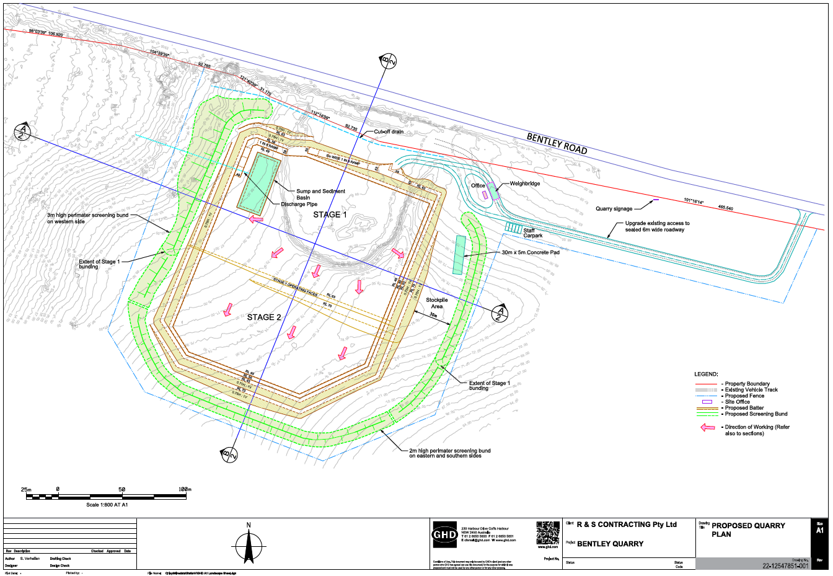

Appendix 2 – Noise Receiver Locations
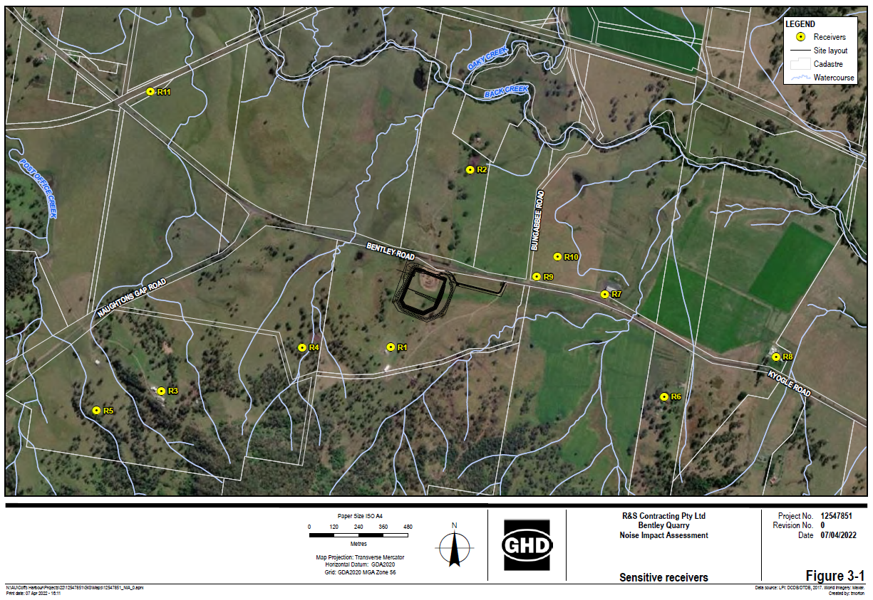

Appendix 3 – Conceptual Rehabilitation Plan
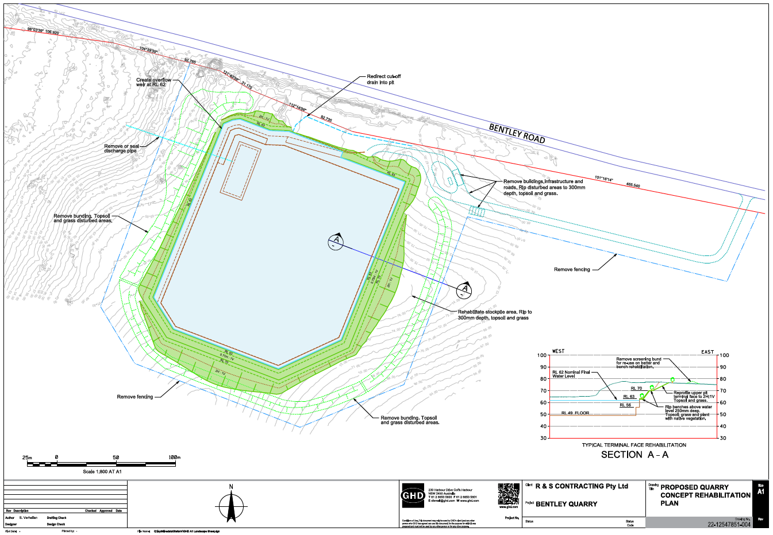

Appendix 4 – Offset Planting and Nest Box Area
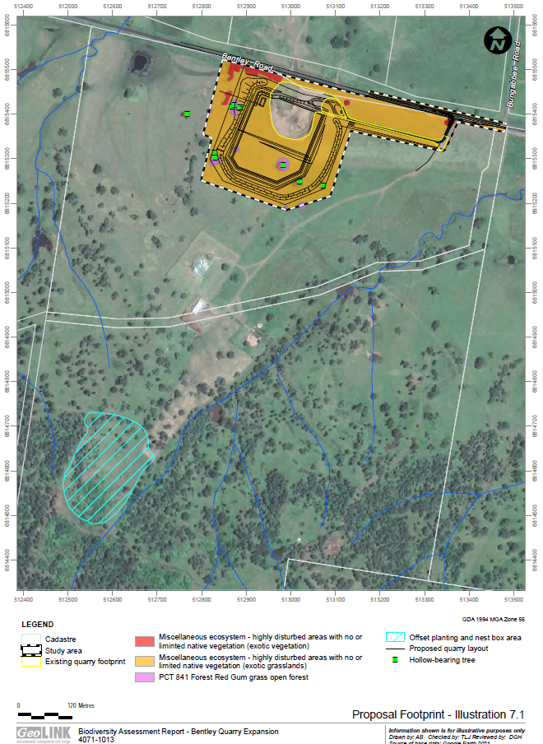

INFORMATION TO APPLICANTS

ADVISORY NOTES
NOTE 1: Prior to commencing any construction works, the following provisions of the Environmental Planning and Assessment Act, 1979 are to be complied with:
(i) A Construction Certificate is to be obtained from the Consent Authority or an Accredited Certifier in accordance with Section 6.7 of the Act.
(ii) A Principal Certifying Authority is to be appointed and Council is to be notified of the appointment in accordance with Section 6.6 of the Act.
(iii) Council is to be given at least two (2) days notice of the persons intention to commence building works, in accordance with Section 6.6 of the Act.

NOTE 2: The applicant may apply to the Council or an Accredited Certifier for the issuing of a Construction Certificate and to be the Principal Certifying Authority to monitor compliance with the approval and issue of any relevant documentary evidence or certificates.

NOTE 3: In accordance with Section 69 of the Environmental Planning and Assessment Regulation, it is a condition of Development Consent for development that involves any building work, that the work must be carried out in accordance with the requirements of the Building Code of Australia.

NOTE 4: If the provision of services or the construction of any infrastructure or any other thing required by this consent occurs, and a GST is payable by Council, the applicant will pay to the Council the GST (as defined below) which is payable by the Council in respect of this consent.

NB: GST means any tax levy charge or impost under the authority of any GST law (as defined by the GST Act) and includes GST within the meaning of the GST Act.

The GST Act means a New Tax System (Goods and Services Tax) Act 1999 or any amending or succeeding legislation.

NOTE 5: This development approval does not guarantee compliance with the Disability Discrimination Act and the developer should therefore investigate their liability under the Act. Council can assist developers by directing them to Parts 2, 3 and 4 of the Australian Standard 1428 – Design for Access and Mobility (Part 1 is mandatory in the BCA).

NOTE 6: The granting of the development consent does not negate the owner/applicant's obligations under Part 6 of the National Parks and Wildlife Act 1974, where it is declared an offence to harm, or desecrate, an Aboriginal object or declared Aboriginal Place. The Office of Environment and Heritage's Due Diligence Code of Practice should be used to determine whether harm is likely, and whether consent in the form of an Aboriginal Heritage Impact Permit (AHIP) is required.
NOTE 7: Underground assets may exist in the area that is subject to your application. In the interests of health and safety and in order to protect damage to third party assets please contact Dial before you dig at www.1100.com.au or telephone on 1100 before excavating or erecting structures (This is the law in NSW). If alterations are required to the configuration, size, form or design of the development upon contacting the Dial before You Dig service, an amendment to the development consent (or a new development application) may be necessary. Individuals owe asset owners a duty of care that must be observed when working in the vicinity of plant or assets. It is the individual’s responsibility to anticipate and request the nominal location of plant or assets on the relevant property via contacting the Dial before you dig service in advance of any construction or planning activities.

NOTE 8: Telstra (and its authorised contractors) are the only companies that are permitted to conduct works on Telstra’s network and assets. Any person interfering with a facility or installation owned by Telstra is committing an offence under the Criminal Code Act 1995 (Cth) and is liable for prosecution.

Furthermore, damage to Telstra’s infrastructure may result in interruption to the provision of essential services and significant costs. If you are aware of any works or proposed works which may affect or impact on Telstra’s assets in any way, you are required to contact : Telstra’s Network Integrity Team on Phone Number 1800 810 443.

PRESCRIBED CONDITIONS OF DEVELOPMENT CONSENT
Under the provisions of Section 69 of the Environmental Planning and Assessment Regulation for the purposes of Section 4.17(11) of the Environmental Planning and Assessment Act the following conditions are Prescribed Conditions:

1. All building work must be carried out in accordance with the provisions of the Building Code of Australia.

Reason: Required by Section 69 of the Regulation.

2. In the case of residential building work for which the Home Building Act 1989 requires there be a contract of insurance in force in accordance with Part 6 of that Act, that such a contract of insurance is in force.

Reason: Required by Section 69 of the Regulation.

3. Any Development that requires building work, subdivision work or demolition work a sign must be erected on the development site in a prominent position before the commencement of any work showing:
a) Name, address and telephone number of the Principal certifying Authority for the work.
b) Name of the Principal Contractor (if any) for any building work and a telephone number on which that person may be contacted outside working hours.
c) Stating that unauthorised entry to the work site is prohibited.

NOTE: The sign must be of rigid and durable material and maintained on the site until work has been completed. The sign must be easily read by anyone in any public road or public place adjacent to the site.

Reason: To ensure compliance with Section 4.17(11) of the Environmental Planning and Assessment Act, 1979 and Section 70 of the Accompanying Regulation.

4. If the development involves an excavation that extends below the level of the base of the footings of a building, structure or work (including any structure or work within a road or rail corridor) on adjoining land, the person having the benefit of the development consent must, at the person’s own expense:
(a) protect and support the building, structure or work from possible damage from the excavation, and
(b) where necessary, underpin the building, structure or work to prevent any such damage.

The above requirements do not apply if the person having the benefit of the development consent owns the adjoining land or the owner of the adjoining land has given consent in writing to that condition not applying.

Reason: To ensure compliance with Section 4.17(11) of the Environmental Planning and Assessment Act, 1979 and Section 74 of the Accompanying Regulation.

DATE FROM WHICH CONSENT OPERATES
Sections 4.20 and 8.13 of the Environmental Planning and Assessment Act provides that the consent shall become effective and operate from the date endorsed upon the notice, except in the case of designated development to which objections have been lodged, when the consent shall become effective 28 days after the consent is issued.

Where an appeal is lodged, either by the applicant or an objector in respect of designated development, the consent shall remain in deferment and not become effective until the appeal has been determined. The consent shall be void if, on appeal, the development is refused.

COMPLIANCE
The development shall be carried out in accordance with the application, and “approved plans” as may be attached to this consent, and as amended by the foregoing conditions. All conditions shall be complied with prior to occupation of the development and, where appropriate, during the operating life of the development.

REVIEW OF DETERMINATION
Under the provisions of Sections 8.25 to 8.5 of the Environmental Planning and Assessment Act 1979, an applicant may request the Council to review a determination of the application. The request for a review must be made within six (6) months after the date of the determination.

RIGHT OF APPEAL
If you are dissatisfied with this decision, Sections 8.7 and 8.10 of the Environmental Planning and Assessment Act 1979 gives you the right of appeal to the Land and Environment Court within six (6) months after the date on which you receive this notice.

Where an appeal is made in the case of a designated development, each person who objected is required to be given notice of the appeal, and will have the right to be heard at that hearing.

Except in the case of designated development, there is no provision within the Act for a third party (objector) to appeal against the consent issued by the Council.

LAPSING OF CONSENT
Section 4.53 of the Environmental Planning and Assessment Act provides that a development consent lapses five years after the date from which it operates. Therefore, this consent lapses five years from the date of operation of this consent UNLESS:

- building, engineering, or construction work relating to this development is commenced on the land within the period of operation of the consent, or

- if no such works are required, the use of the premises commences within the period of operation of the consent.

MODIFICATION OF CONSENTS
Under the provisions of Section 4.55 of the Environmental Planning and Assessment Act an applicant may apply to Council for modification of the consent.

NOTICE TO COMPLETE
Where development has been commenced, but the work not completed, Schedule 5 provides that the Council may issue an order requiring completion of the work within a specified time, being not less than twelve months.

For and on behalf of Richmond Valley Council.

per: Andy Edwards
Manager Development
and Certification

Encl.

